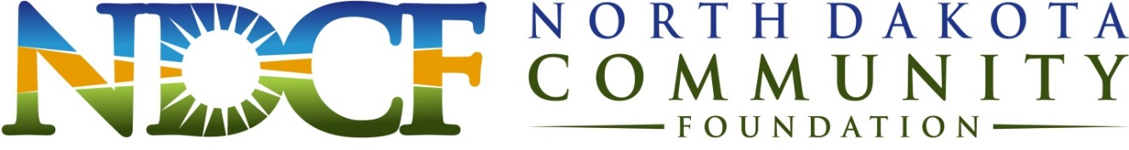

Our Mission: To improve the quality of life for North Dakota’s citizens through charitable giving and promoting philanthropy.

Advisory Committee Candidate Data Form

This form is designed to help the NDCF’s Board identify potential local community advisory committee member interests and experience and how these talents can assist the local fund in accomplishing its mission.

Name: (Include professional designations, i.e. M.S.W., Ph.D., etc.)

Occupation/Vocation: (Note if retired)

Title/Position:

Address:

Phone:

Mobile Phone:

Fax:

Email(first priority for communication):

Boards and committees you currently serve on or have served on, along with any other community volunteer activities:

How do you feel that the local foundation will benefit from your involvement on the board?

Please tell us anything else you’d like to share.

Professional Background/Relevant Skills/Areas of Expertise (check all that apply):
Communications:
◻ Marketing
◻ Media
◻ Meeting/Event Planning
◻ Public Relations
Community Leadership:
◻ Advocacy/Public Policy
◻ Arts
◻ Human Services and/or Youth
Development
◻ Prior Nonprofit Board Experience
◻ Volunteer Management
Legal/Administrative:
◻ Accounting
◻ Finance
◻ Legal
Resource Development:
◻ Fundraising
◻ Human Resources
◻ Information Technology

Additional Areas of Expertise or Resources:

Thank you for your interest in serving on the Walhalla Advisory Committee!

